The Thompson Project

**Project Management Plan**

*September 2022*

**Version** 1.1

**Revision History**

| **Date** | **Version** | **Description** | **Author** |
| --- | --- | --- | --- |
| 9/8/2022 | 1.0 | Started draft and added basic information | Team Ponyo |
| 9/11/2022 | 1.1 | Embedded files needed | Team Ponyo |
| 9/14/2022 | 1.2 | Embedded missing files | Team Ponyo |
| 10/19/2022 | 1.3 | Added descriptions to embedded files | Team Ponyo |

**Table of Contents**

1. Introduction 3

1.1. Project Overview 3

1.1.1 Executive Summary

1.1.2 Project Charter 3

1.1.2.1 Scope Statements 3

1.1.2.2 Goals and Objectives 3

1.1.2.3 Project Organization 4

1.2. Stakeholders and Key Personnel 4

2. Monitoring and Control Mechanisms 4

3. Systems Security Plans and Requirements 4

4. Work Breakdown Structure (WBS) and Schedule 4

5. Project Success Criteria 5

6. Budget 5

7. Communication Management Plan 5

8. Risk Management Plan 5-6

9. Project Schedule 6

10. Entity Relationship Diagram 6

11. User Flow Diagram 7

12. System Architecture Design 7

13. Requirements Traceability Matrix 7

14. Project Measurement Plan 7

14.1. Description 7

15. Reference Materials 7

Approval Signatures 8

# Introduction

This PMP describes the project management processes that *Team Ponyo* will follow during execution of The T*hompson Project*. The project’s processes will align with plans and processes of the Project Management Accountability System (PMAS) Guide New processes will be defined for any management areas not covered by the PMAS Guide. This PMP will govern the management practices across the life of the project. As those practices evolve, this document will be updated to reflect the changes.

## Project Overview

**1.1.1 Executive Summary**

The objective is to create a website for an organization. The non-profit organization The Thompson Project needs a website to provide assistance to the juveniles students, volunteers, and donors. Statement of work is embedded.



**1.1.2 Project Charter**

Outlines the process of the project including who the project is for, who is working on the project, the scope and deliverable due dates, what is needed for the success of the project and what could happen with the project.Project Charter is embedded.



**1.1.2.1 Scope Statements**

Explains the purpose and the business justification of the project. See project charter.

**1.1.2.2 Goals and Objectives**

Lists the deliverables and the dates they are due, the project milestones, the assumptions, constraints, and the dependencies of the project. See project charter.

**1.1.2.3 Project Organization**

Includes when different deliverables are due and the criteria regarding them. Keeping track of what is needed for the project and the obstacles that may present itself. See project charter.

## Stakeholders and Key Personnel

-Employees

-Volunteers

-Juveniles

-Parents of juveniles

# Monitoring and Control Mechanisms

This project follows standard monitoring and control processes as defined in ProPath for risk management, requirements traceability, and operational readiness.

# Systems Security Plans and Requirements

System security plans and requirements will be developed as part of the project’s planning phase.

# Work Breakdown Structure (WBS) and Dictionary

| **Deliverable** | **Due Date** | **Dictionary** |
| --- | --- | --- |
| Demo I | 10/24/22 | ~50% Development completed. |
| Demo II | 11/14/22 | No less than 75% Development completed. |
| Final Demo | 12/5/22 | 100% Development, fully functional website. |

# Project Success Criteria

“Success” will be based on the feedback received after the Demo presentations. Our team will work to create a fully functional website that will include all requirements given, in order to help The Thompson Project expand its reach and generate funding.

# Budget

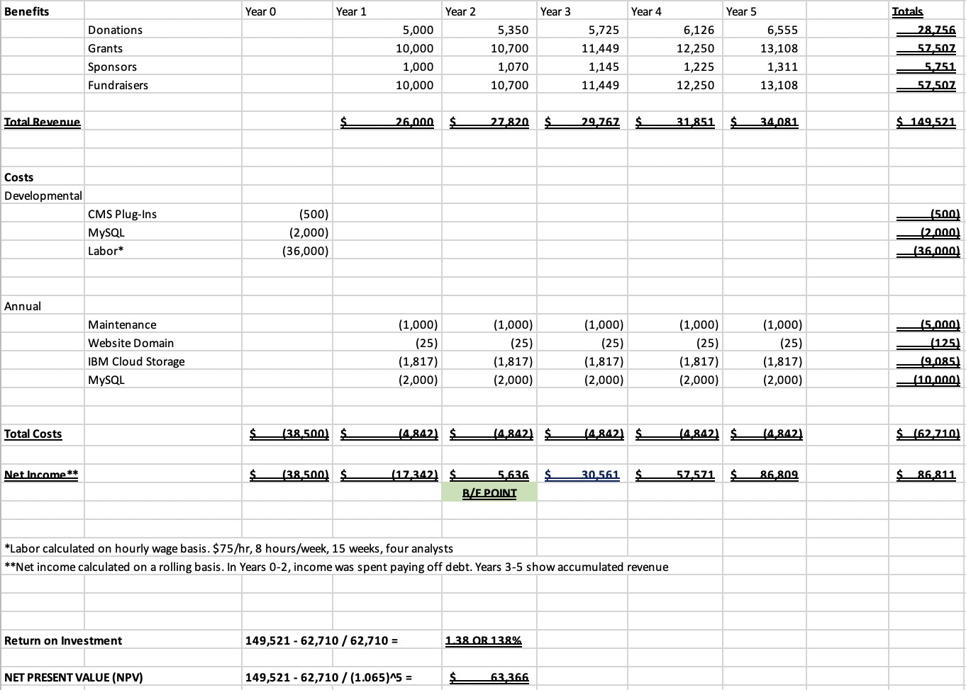

# Communication Management Plan

Communication with the Project Sponsor and Client are crucial in order to develop the most functional website possible. In order to be “successful,” we will take all feedback from the Demo’s and apply them before the succeeding Demo’s. Any changes to the scope should also be communicated clearly in order for everyone to be on the same page.

# Risk Management Plan

**The risks that may be encountered:**

- Funding may unexpectedly decrease.

- Juvenile information could be stolen if not properly secured.

- Card information could be stolen if not transacted and secured properly.

- Software and hardware may encounter issues if not maintained and updated.

- Having up to date parental contact information if an issue may occur with a Juvenile student.



**Measures taken to mitigate risk:**

- Have an alternative plan with a lower budget in the event of funding unexpectedly decreasing.

- Keep sensitive information on a secured and encrypted database so that it is adequately protected.

- Using PayPal, establish a very secure payment method and process.

- Applications should be implemented that automatically alert administrators of software/hardware that needs to be updated.

- Parental contact information should be reviewed and confirmed periodically.

# Project Schedule

| **Deliverable** | **Due Date** |
| --- | --- |
| Demo I | 10/24/22 |
| Demo II | 11/14/22 |
| Final Demo | 12/5/22 |

**10. Entity Relationship Diagram**



Above is the Entity Relationship Diagram for our website. This diagram is a relationship model of all of the “entities” or concepts of the website, and shows how they relate to one another through the use of cardinalities. The ERD helps model and design regional databases, analyze these databases if there are any logic errors, and also play a large role in the engineering of any new models that may come if there are changes within the scope.

**11. User Flow Diagram**



This embedded file is the User Flow Diagram. It diagrams the complete path a user takes when using the website. It consists of buttons, forms, and windows. This is the layout for the website and every condition needs to be met.

**12. System Architecture Design**



This embedded file is the System Architecture Diagram. It illustrates the flow of information throughout the system. For example, what route a donation would follow to the paypal server. It’s simply just an abstract diagram of the relationship between pieces of the system architecture.

**13. Requirements Traceability Matrix**



This embedded file is the Requirements Traceability Matrix. It allows the ability to keep track of all the use case requirements and ensures they are met. Each requirement’s progress is labeled.

# 14. Project Measurement Plan

## 15.1 Description

# 15. Reference Materials

* Project Charter
* Statement of Work

**Approval Signatures**

| Signatures: | Date: |
| --- | --- |
| Bryndon Tincher | 9/14/2022 |
| HN Lamb | 9/14/2022 |
| Addison Phillips | 9/14/2022 |
| Alexis Bruszewski | 9/14/2022 |
| Tyler Justice | 9/14/2022 |